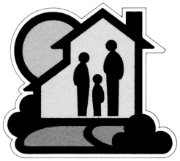

Kansas City, Kansas
Housing Authority
1124 North Ninth Street
Kansas City, KS 66101-2197
(913) 281-3300 FAX (913) 279-3439
________________________________________________________________________

July 24, 2024

NOTICE OF AWARD

Architect & Engineering Contract Awards
Ten Projects 2023

Please be advised that the Housing Authority of Kansas City, Kansas has authorized five new projects for A/E Contracts.

The contracts were awarded as follows:

1. K1-2 St. Margaret’s Park Family Development HVAC Improvements (DAVIDSON & ASSOC)

2. K1-52 Family North Roof & Exterior Replacement (DAVIDSON & ASSOC)

3. K1-20 Westgate Tower & K1-22 Westgate Villas Parking Lot Improvements (DAVIDSON & ASSOC)

4. K1-All Park & Playground Equipment (B+A ARCHITECTURE)

5. K1-58 Vaughn Dale Exterior Repairs (VERITAS ARCHITECTURE & DESIGN)

Sincerely,

cc: Susan Martin file
Maria Felhaber Jeremy Simon
Modernization Admin Asst Bidders

